# Managing Materialized Views

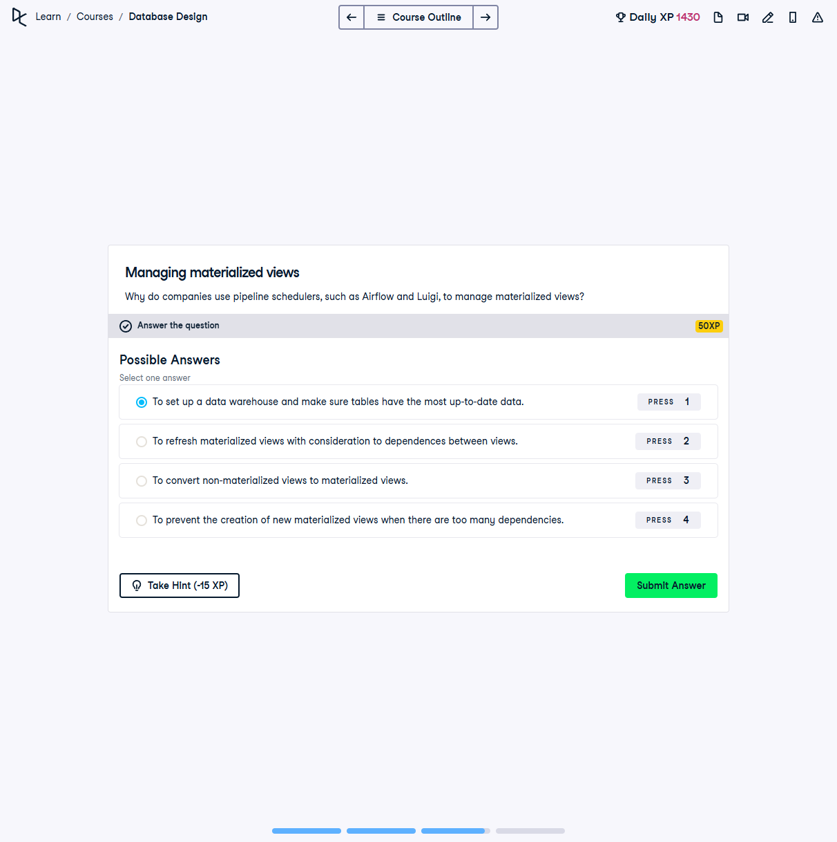

## Question:

Why do companies use pipeline schedulers, such as Airflow and Luigi, to manage materialized views?

## Possible Answers:

1. To set up a data warehouse and make sure tables have the most up-to-date data.

2. To refresh materialized views with consideration to dependencies between views.

3. To convert non-materialized views to materialized views.

4. To prevent the creation of new materialized views when there are too many dependencies.

## Correct Answer:

To refresh materialized views with consideration to dependencies between views.

## Explanation of the Answer:

The correct answer is `To refresh materialized views with consideration to dependencies between views.` Pipeline schedulers like Apache Airflow and Luigi automate the refreshing of materialized views, ensuring that dependencies between views are properly handled and that updates happen in the correct order.